

|  |
| --- |
| **GLS(I&RKD) Institute of Computer Application** |
| Daycare |
|  |
|  |
|  |
|  |
|  |
|  |

# GLS (I&RKD) INSTITUTE OF COMPUTER APPLICATIONS

# GLS Campus, Ellisbridge, Ahmedabad

# **CERTIFICATE**

# This is to certify that

# 1) Laveena Bhatia

# 2) Dhrumin Nagori

# Student/s of Semester-6 BCA (TYBCA), GLS (I&RKD) Institute of Computer Applications has/have successfully completed the System Development Project Part-2, System Analysis work on

# **“ Daycare”**as a partial fulfillment of the study of Third year Semester 6, Bachelor of Computer Applications..

Date of Submission:

Lect. TriptiDodiya Lect. TriptiDodiya

Project Guide Project Co-Ordinator

(Internal)

# Daycare

Developed For

(Daddy Daycare(c/o Angle English School),Ahmedabad.)

Report Part- II (Sem – 6)

Submitted For

The Partial Fulfillment Towards

The Degree of

Bachelor of Computer Applications (BCA)

By

Laveena Bhatia

Dhrumin Nagori

### **Under the Guidance of**

External Guide Internal Guide

(Name) Lect. TriptiDodiya

(Designation) GLS, ICA

(Name of the company) Ahmedabad

# GLS(I&RKD) Institute of Computer Applications

## Ahmedabad

**ACKNOWLEDGEMENT**

We are using this opportunity to express my gratitude to everyone who supported us throughout the project. We are thankful for their aspiring guidance and friendly advice during the project work. We are sincerely grateful to them for sharing their truthful and illuminating views on a number of issues related to the project.

We express our thanks to Mr. KiranNagpure for their support and guidance at Daddy daycare (c/o Angel English School) .

We would like to express our gratitude to our Institute who provided us the inspiration and facility by giving us a chance to make us feel comfortable in the professional environments of the office premises. We would like to thank our project Internal Guide Lect. TriptiDodiya who supported us well and all the people who provided us conductive conditions for our project.

Thank You,

Laveena Bhatia.

Dhrumin Nagori.

**INDEX**

|  |  |
| --- | --- |
| Topic | Page No. |
| Screen Layout   * Admin 7 * CareTaker 31 * User 41 | **6** |
| Report Layout | **59** |
| Bibliography | **63** |
| Conclusion | **64** |

ScreenLayout

**Admin Side**

Login

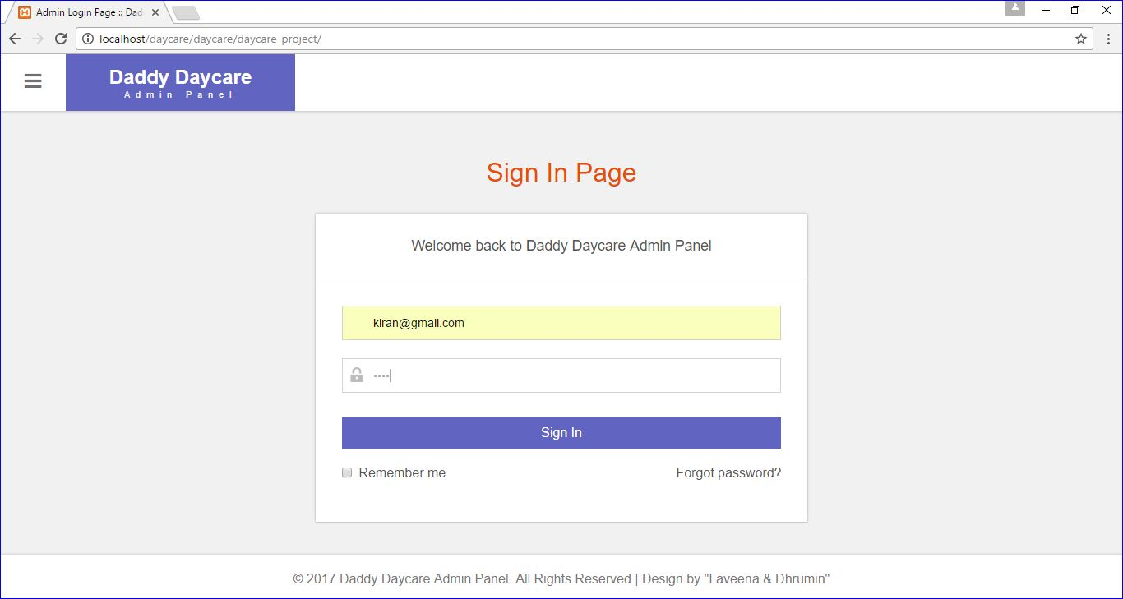

Login Validation

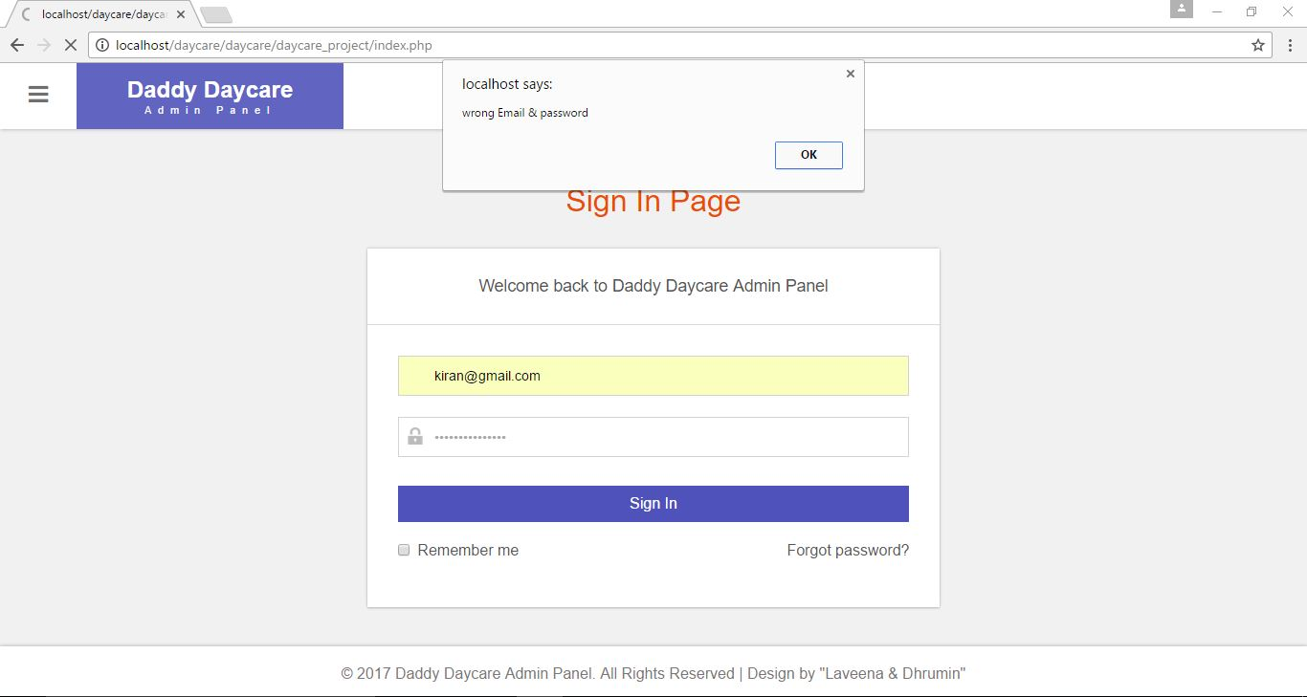

Home

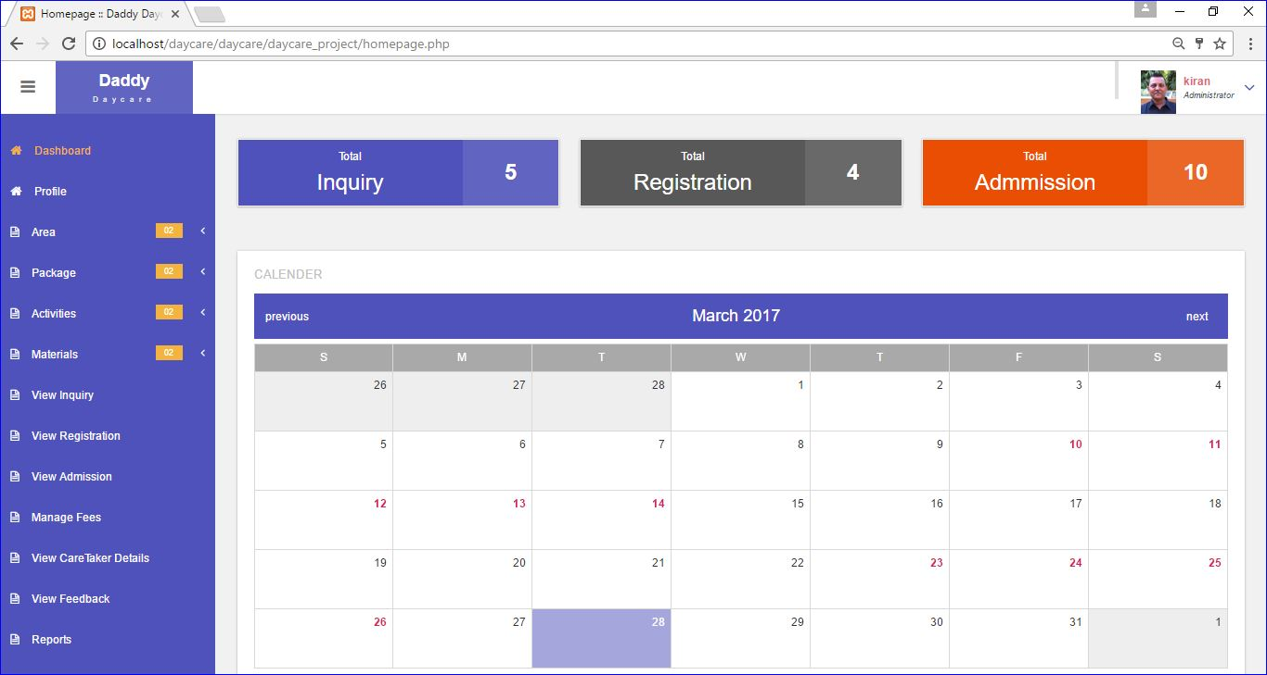

Add Profile

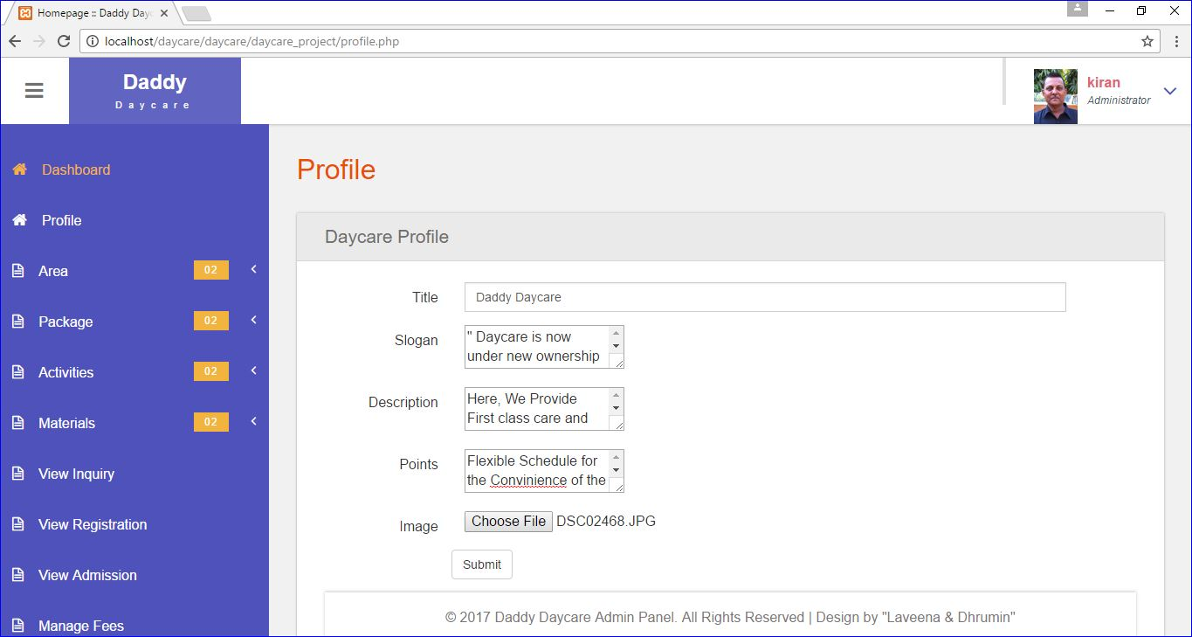

Add Area

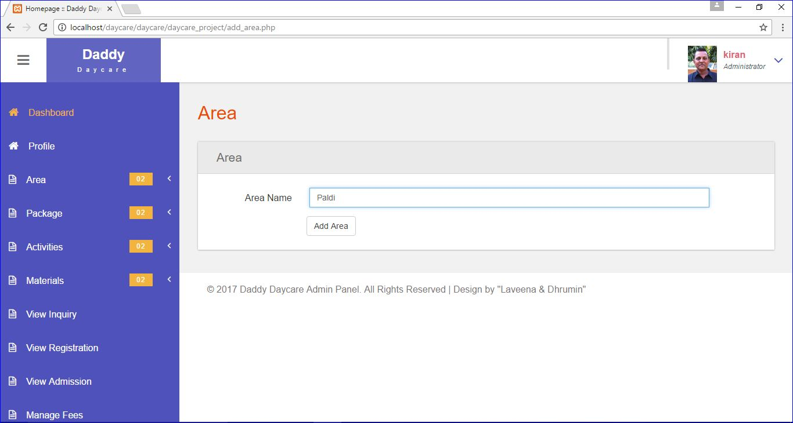

View Area

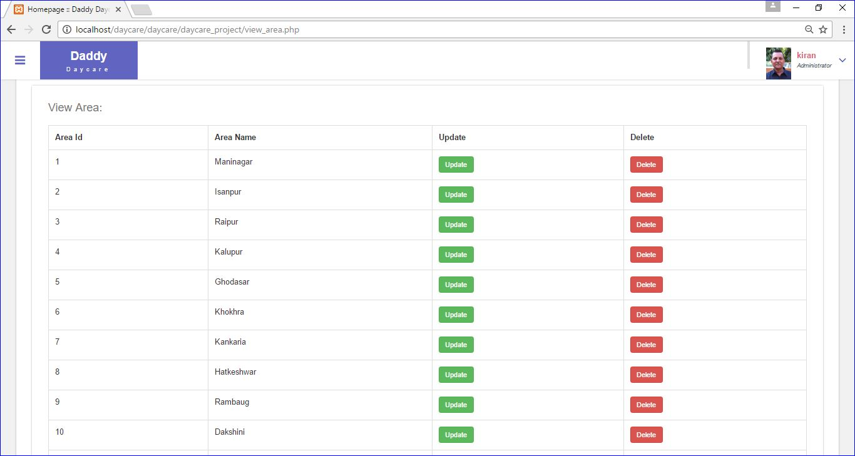

Edit Area

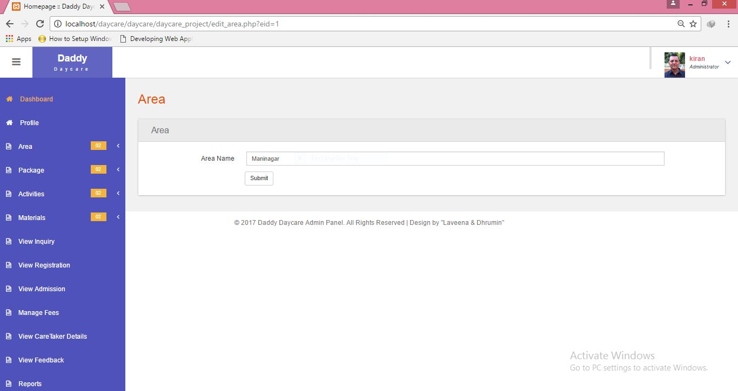

Add Package

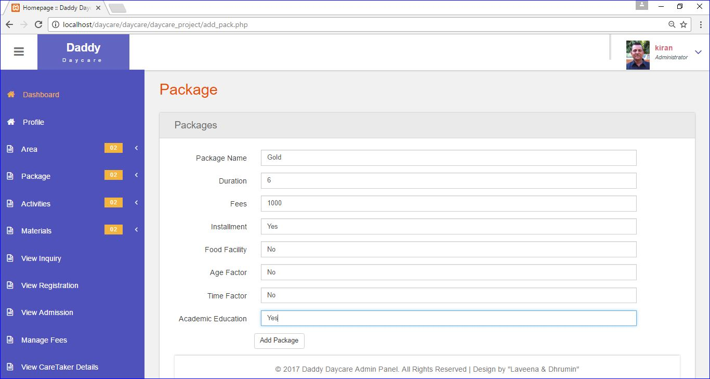

View Package

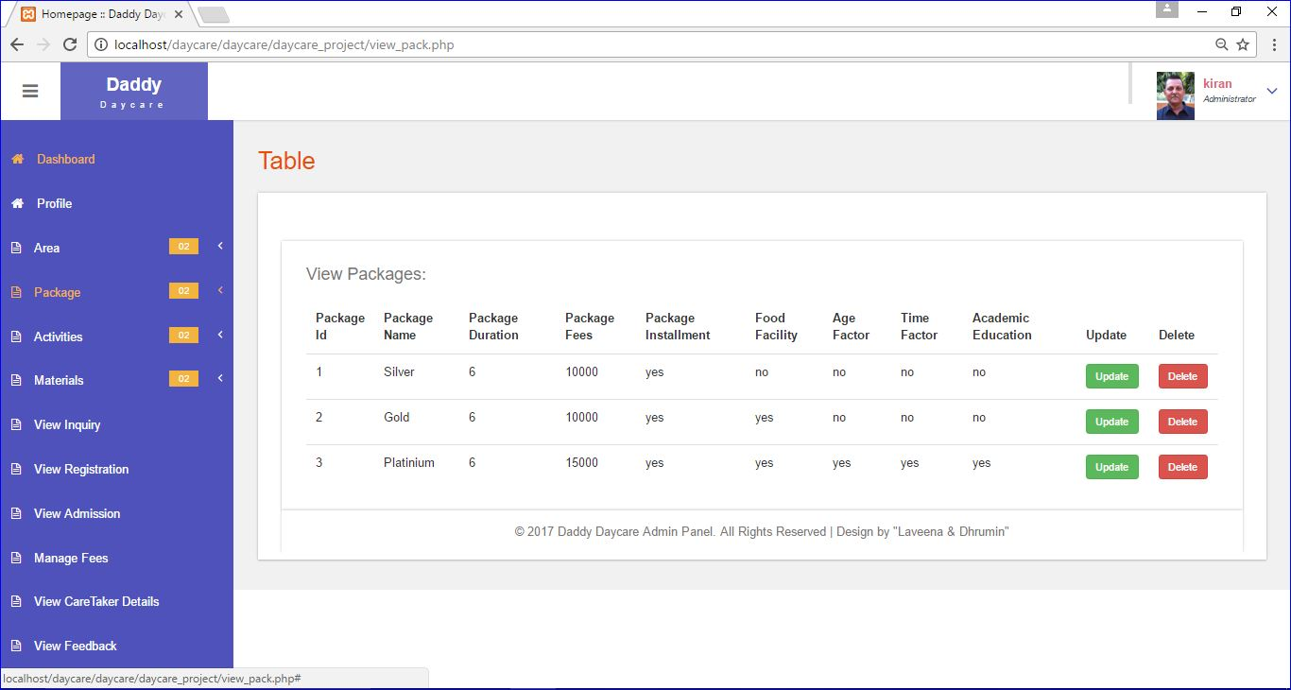

Edit Package

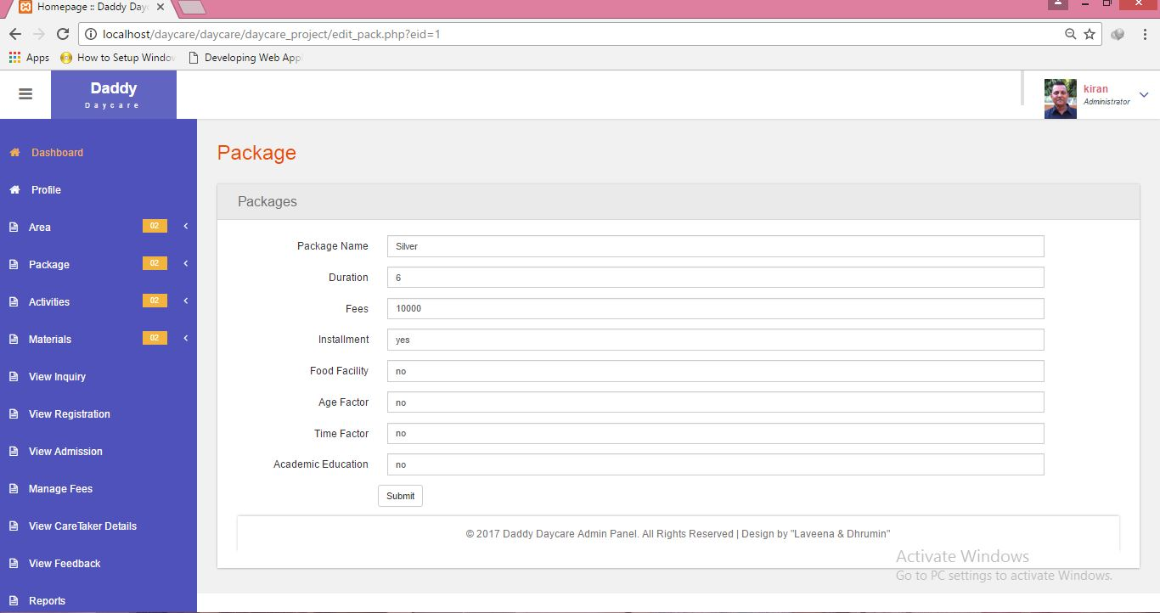

Add Activities

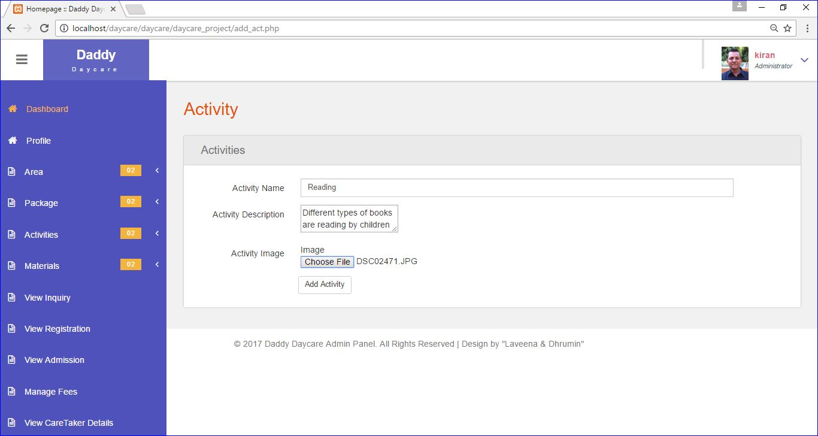

Validation In Activity

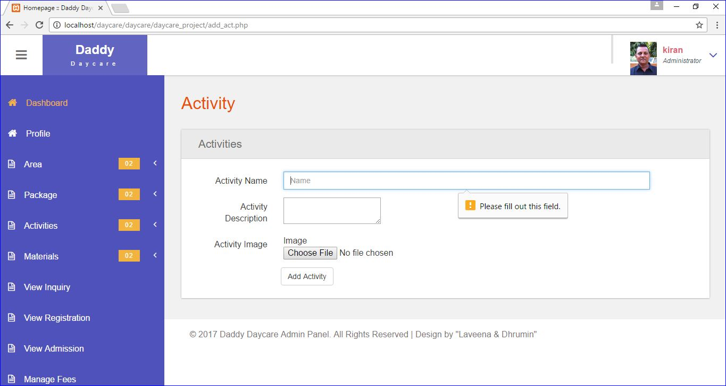

View Activities

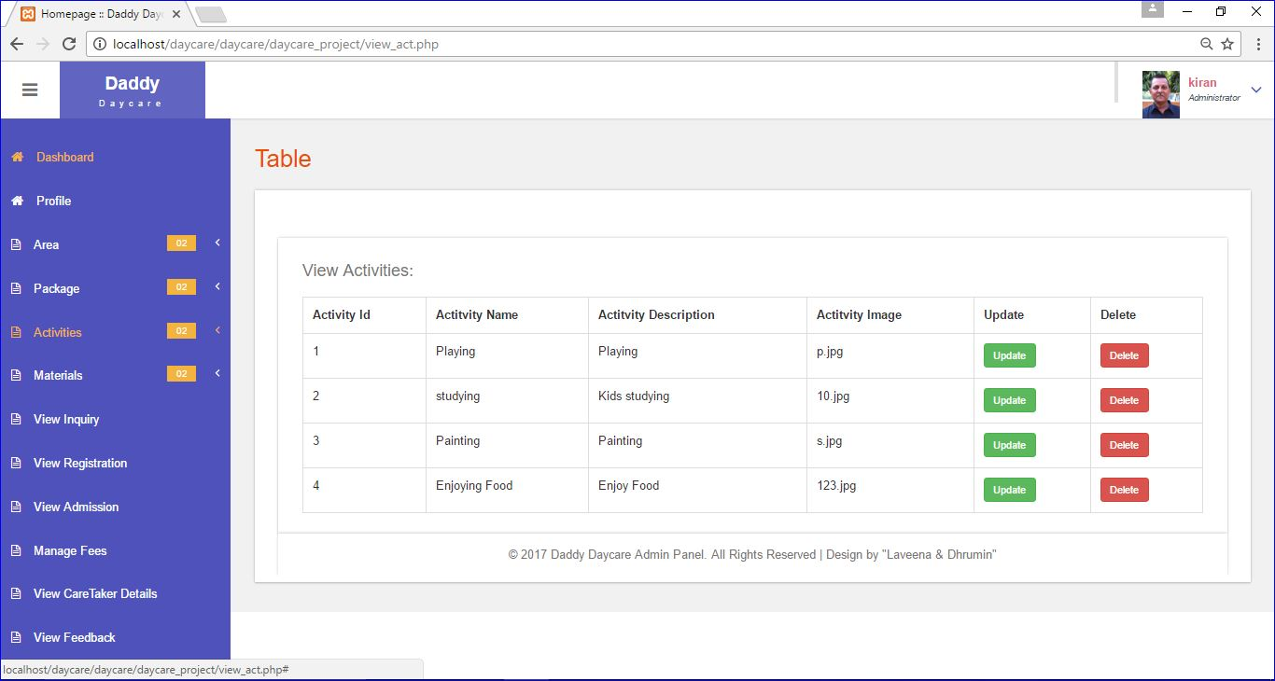

Edit Activities

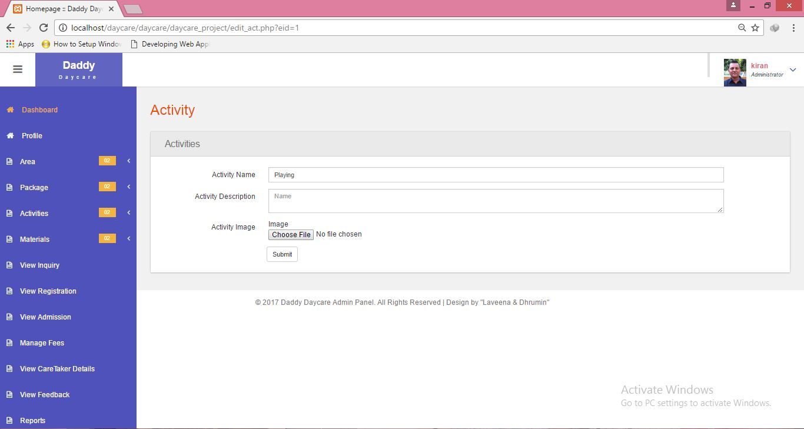

Add Materials

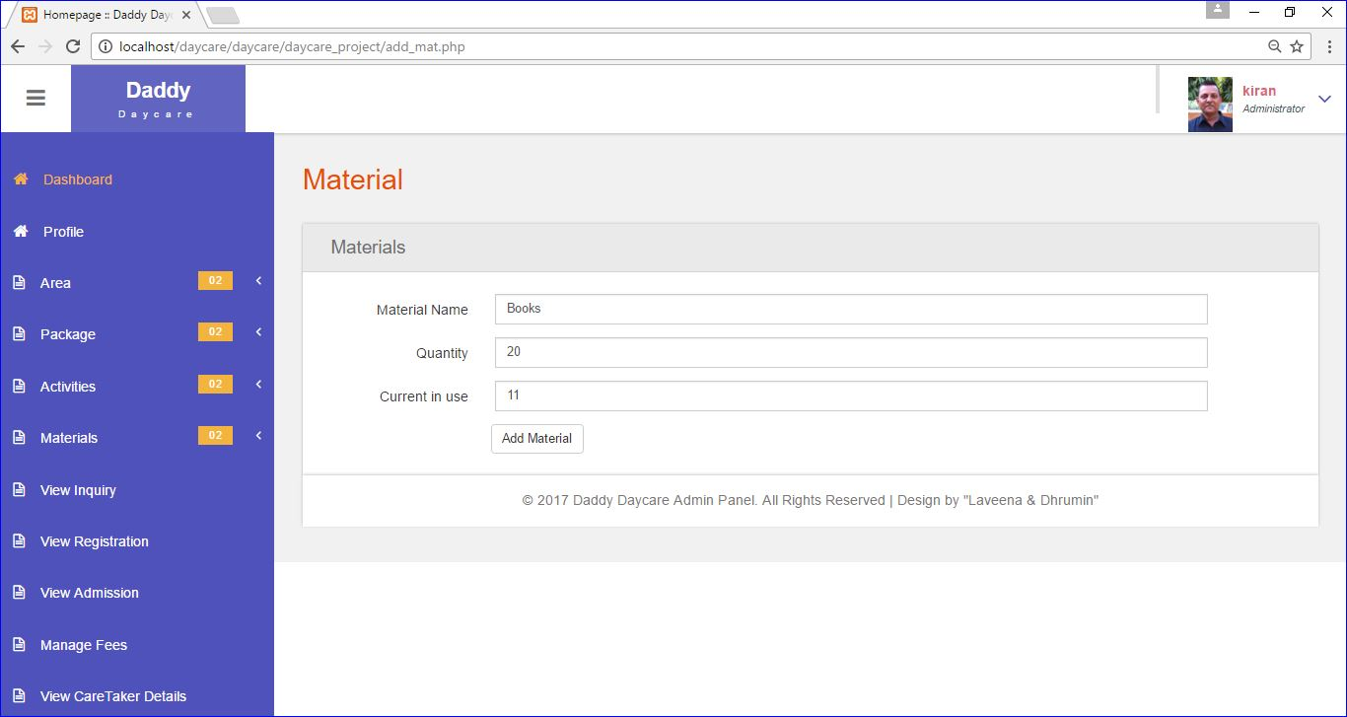

View Materials

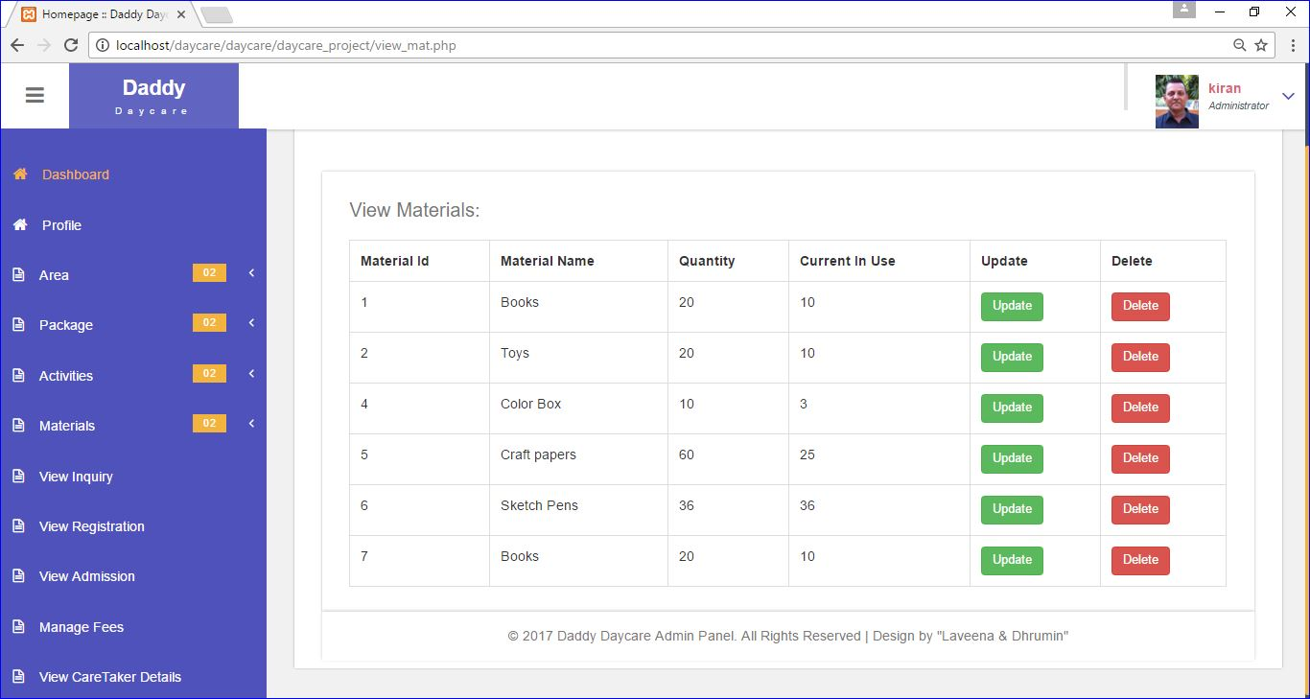

Edit Materials

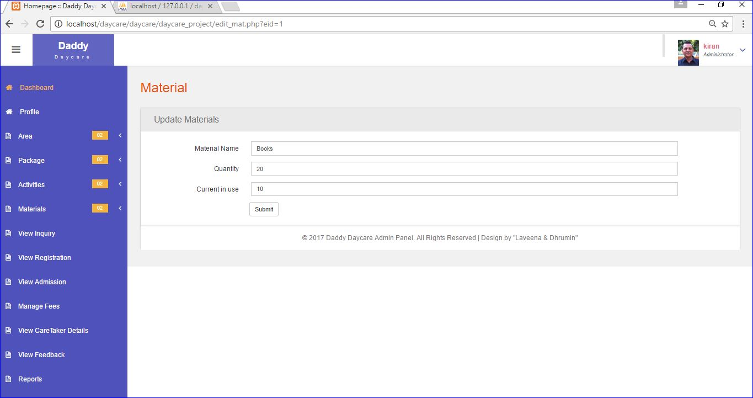

View Inquiry

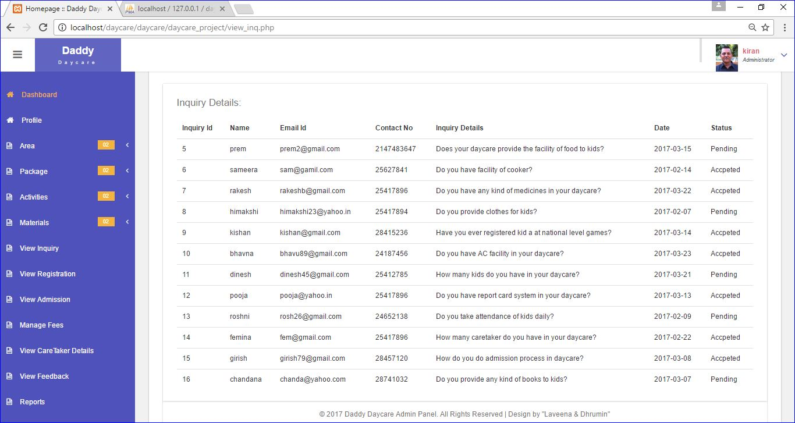

View Registration

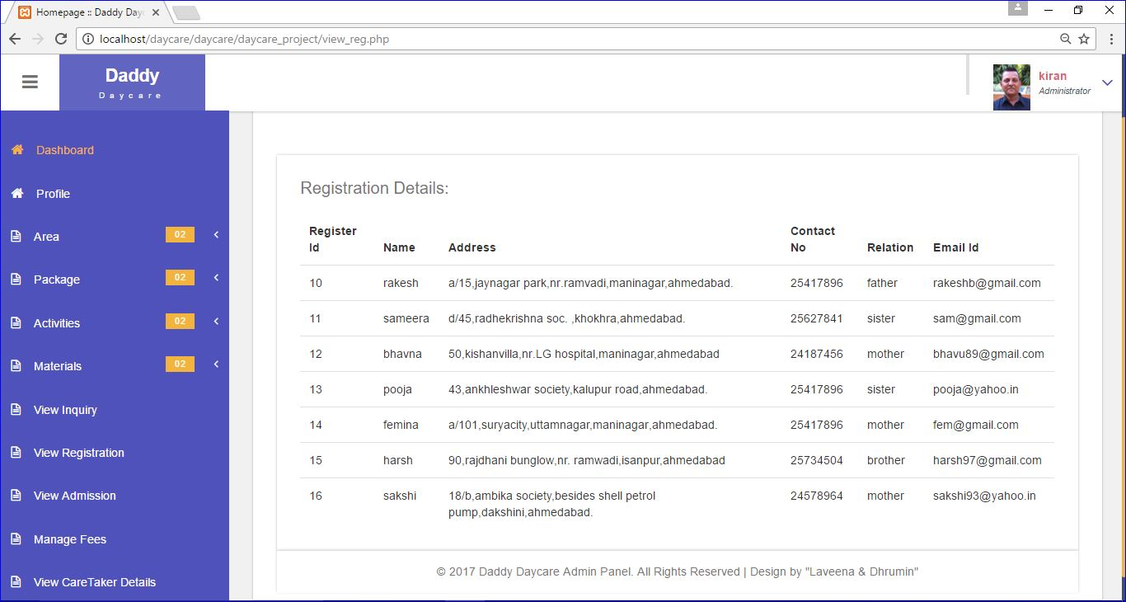

View Admission

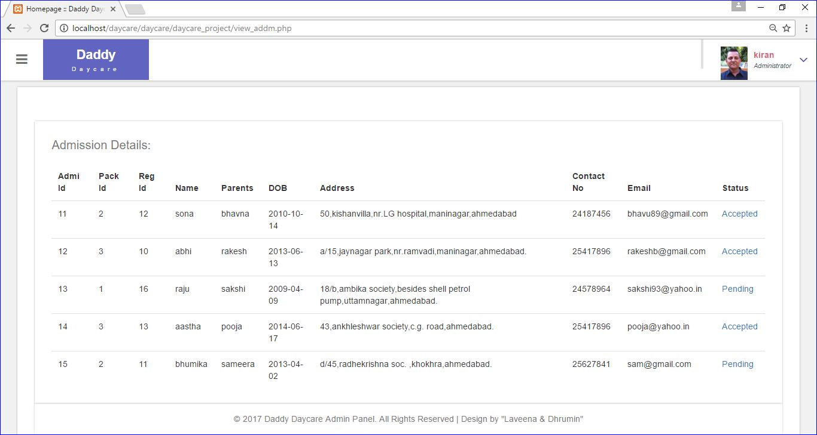

Manage Fees

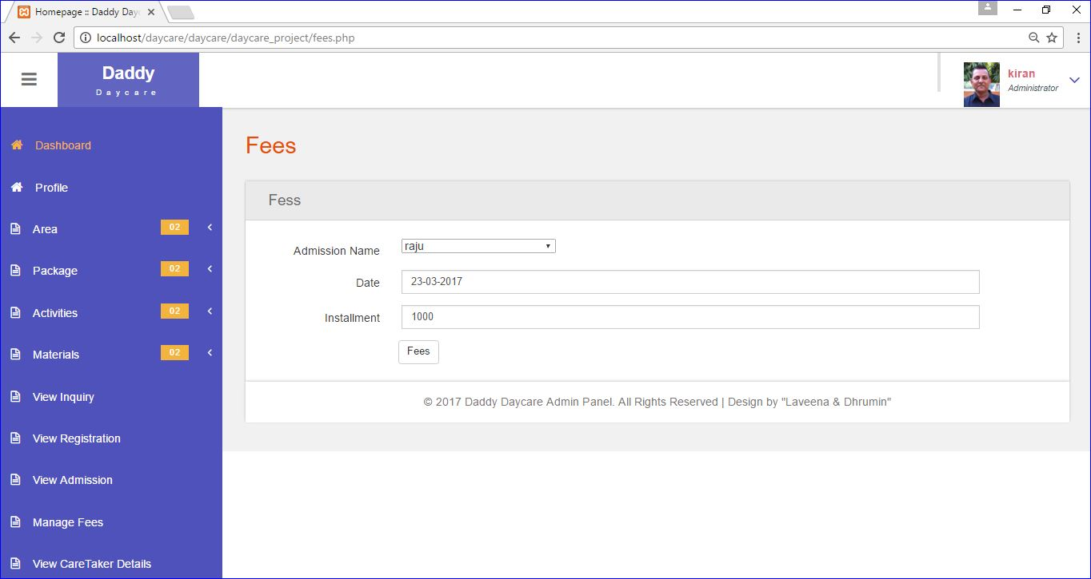

View CareTaker Details

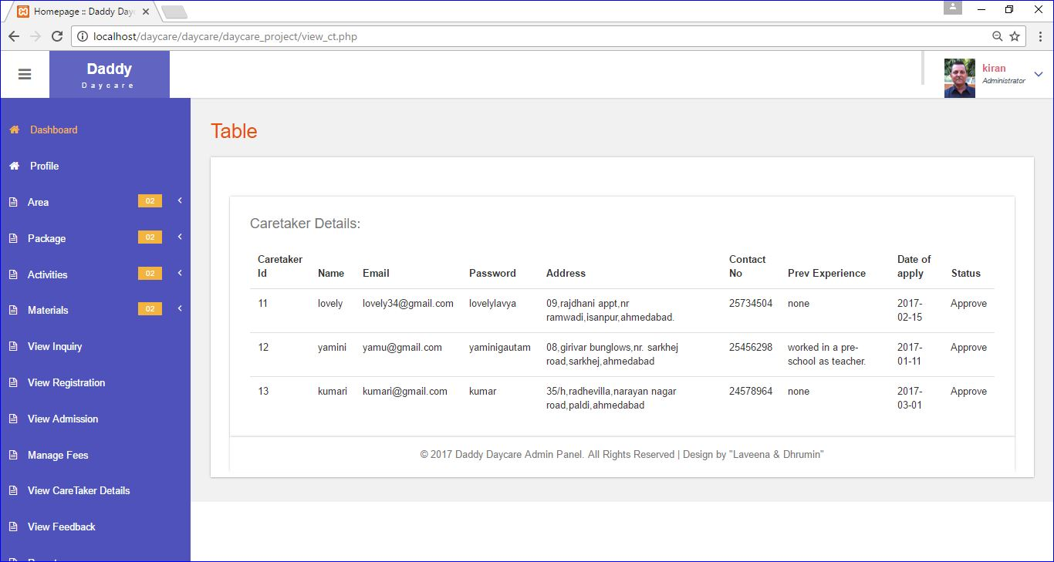

View Feedback

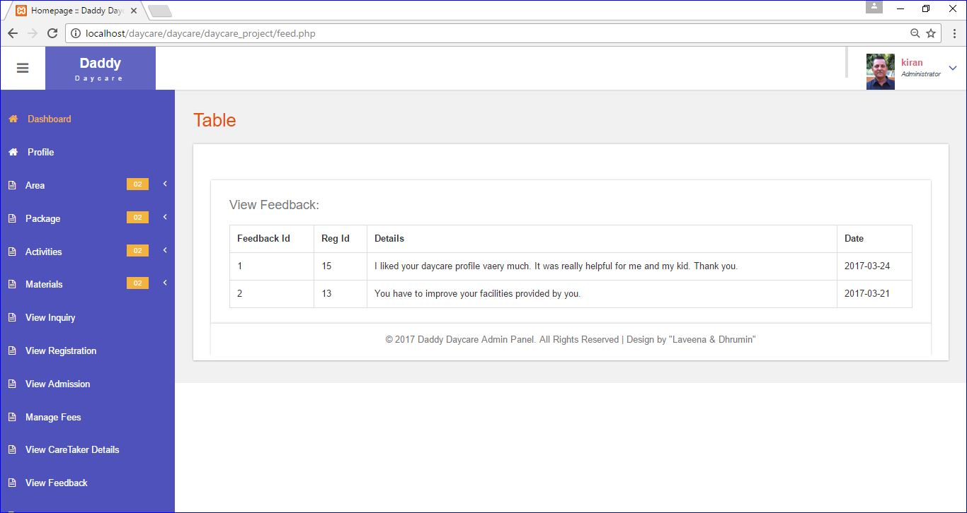

Logout

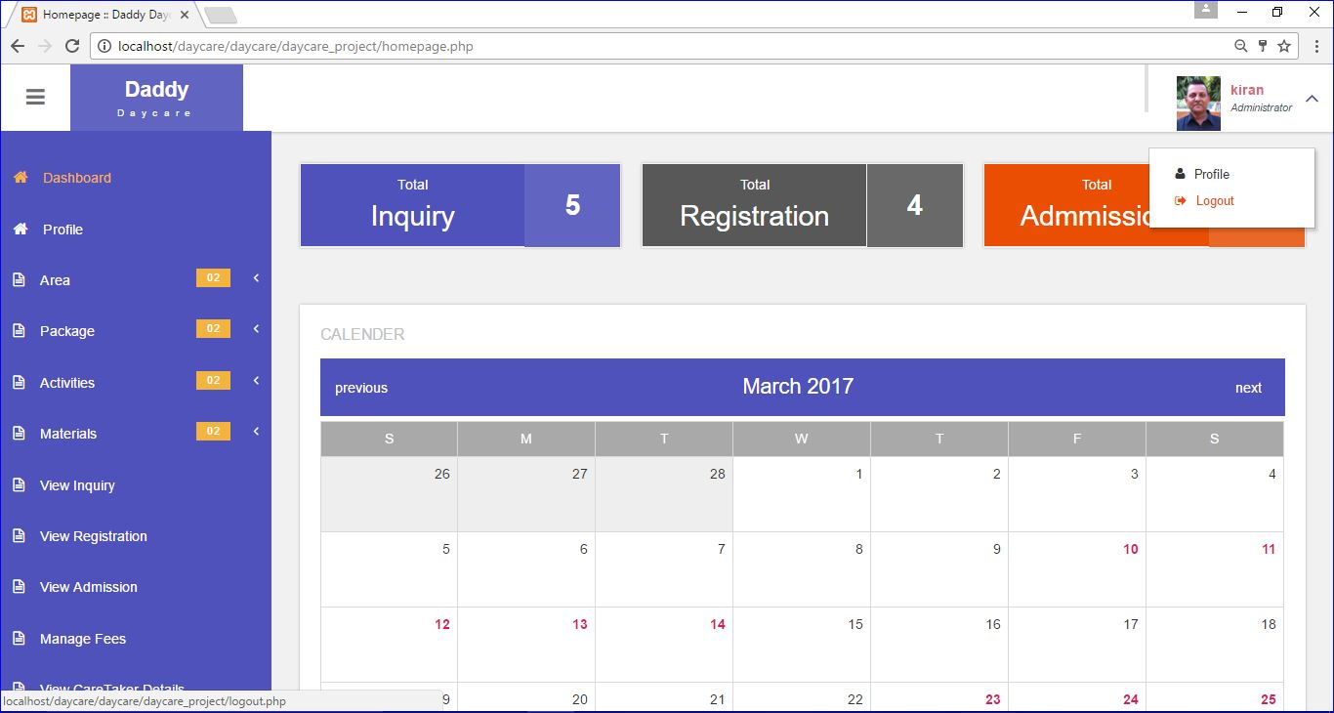

**CareTaker**

CareTaker Login

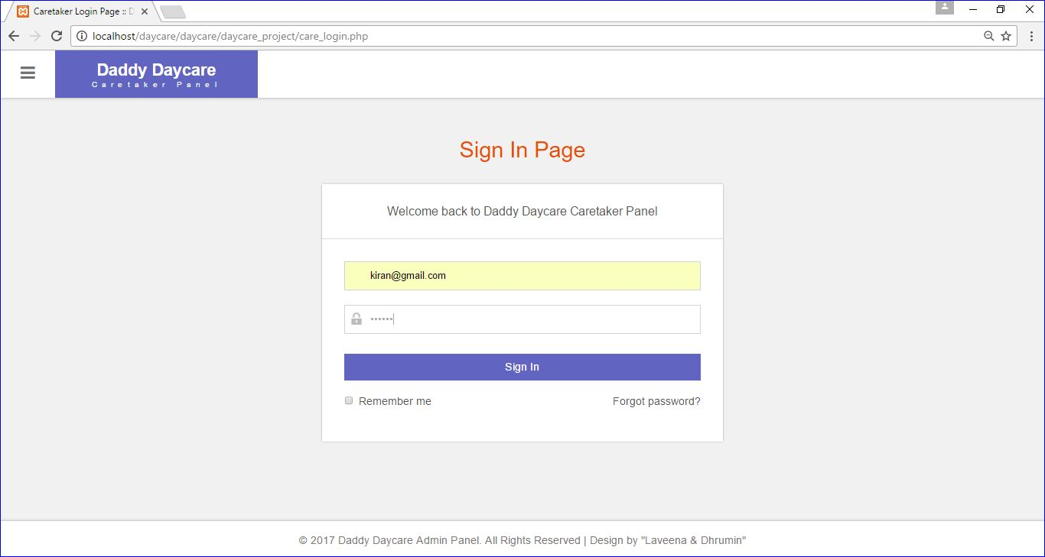

Validation In CareTaker Login

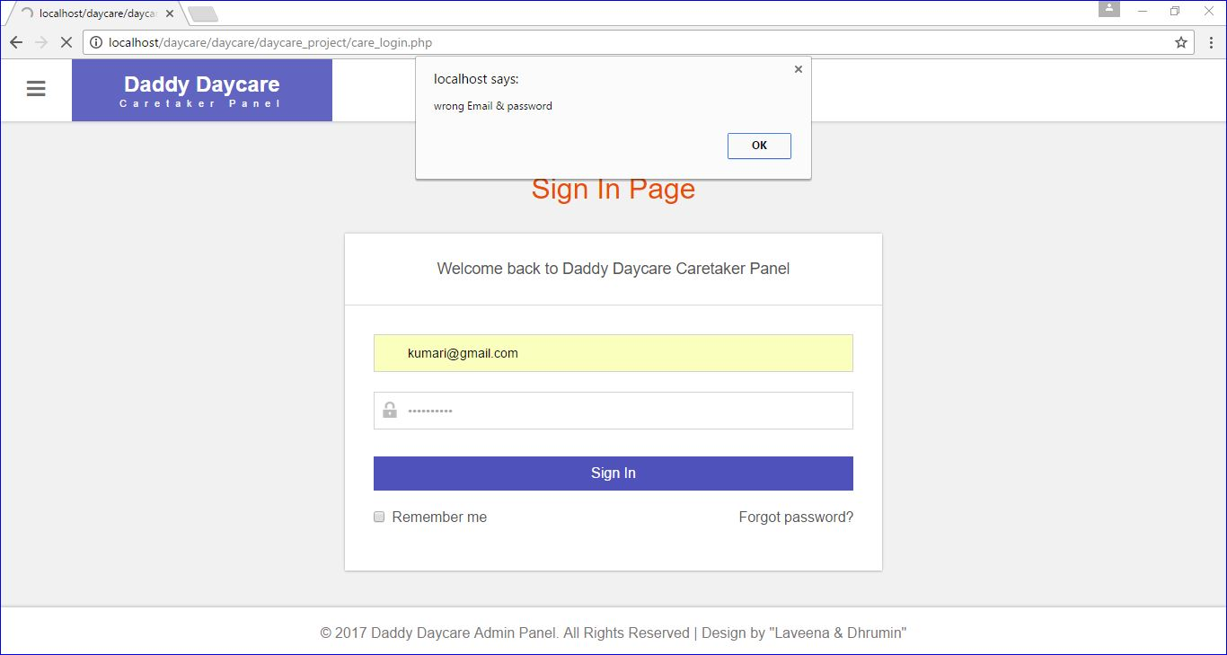

After CareTaker Login

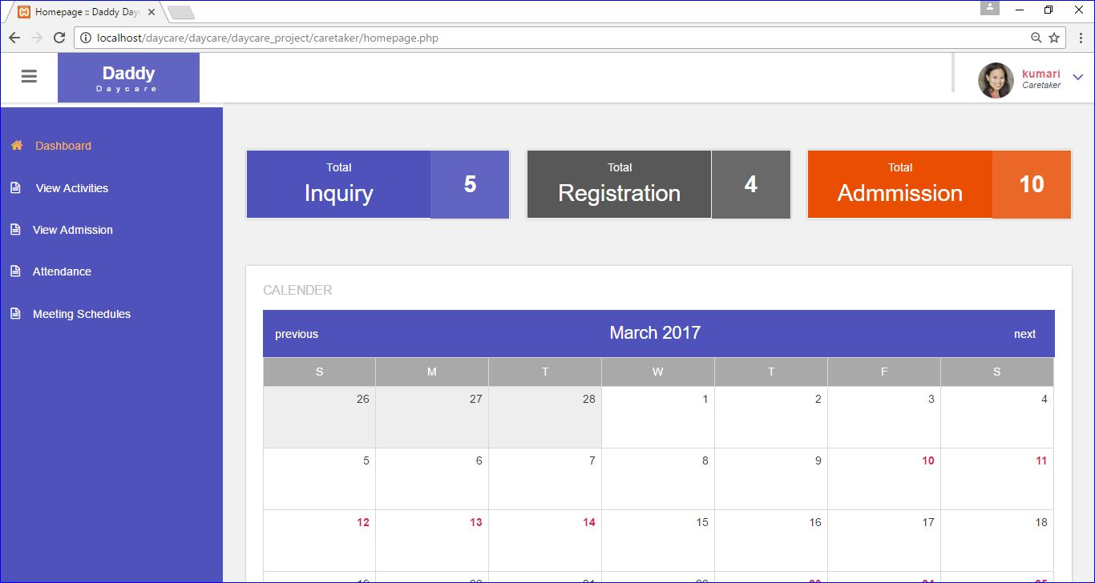

View Activities

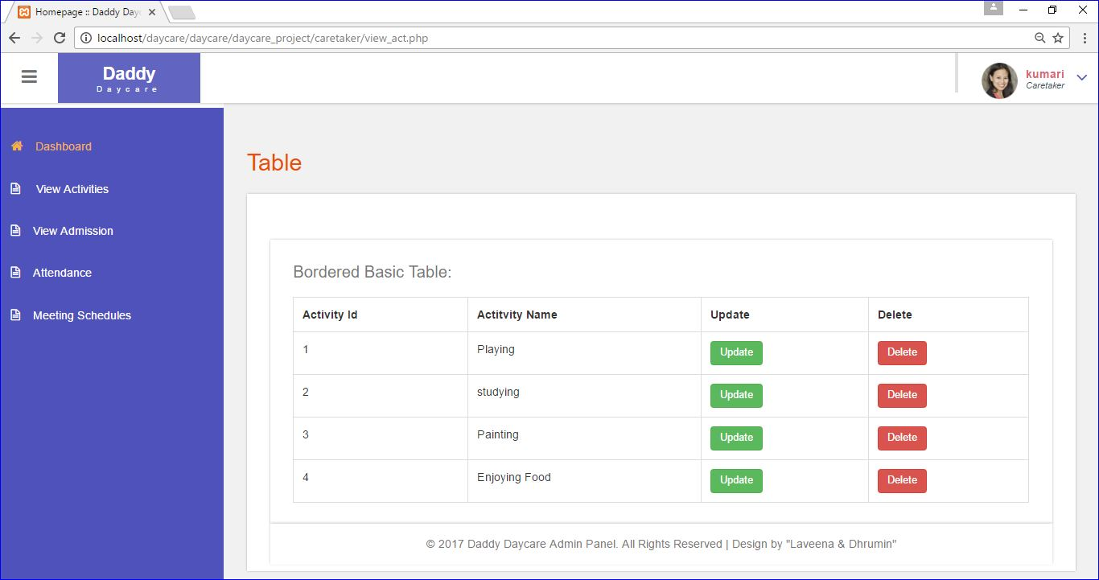

View Admission(If Accepted)

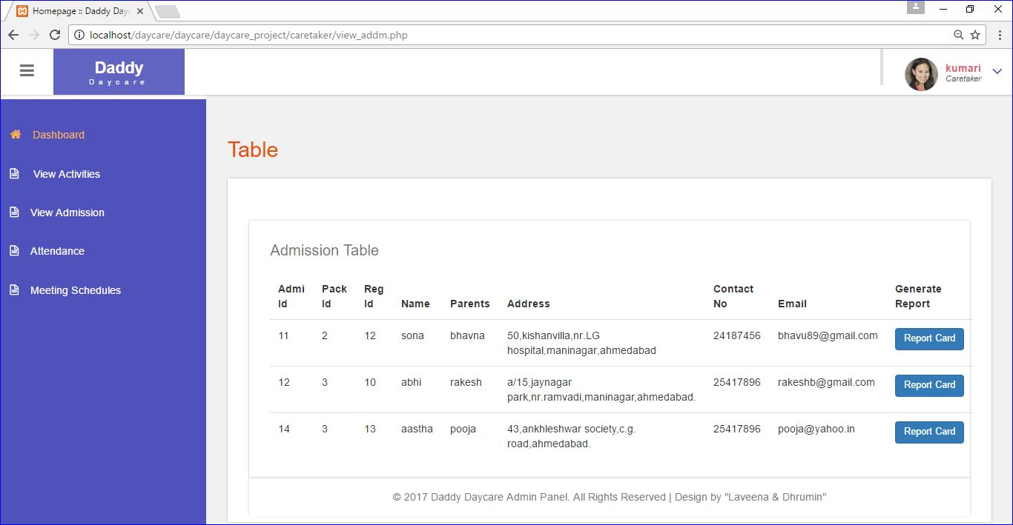

Add ReportCard

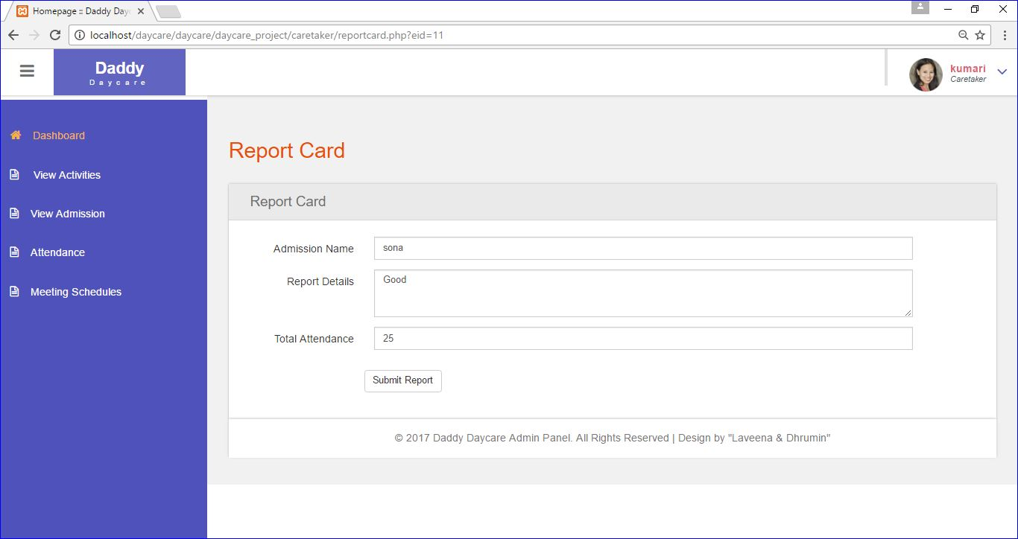

Add Attendance

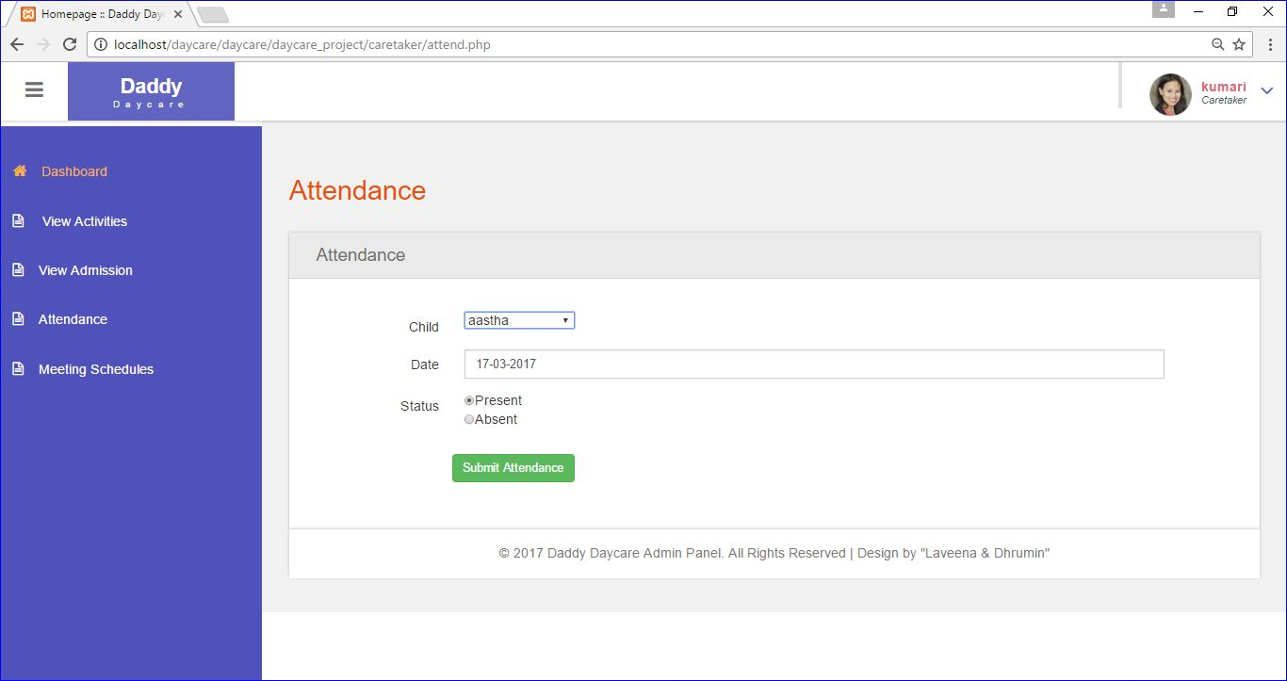

Add Meeting Schedule

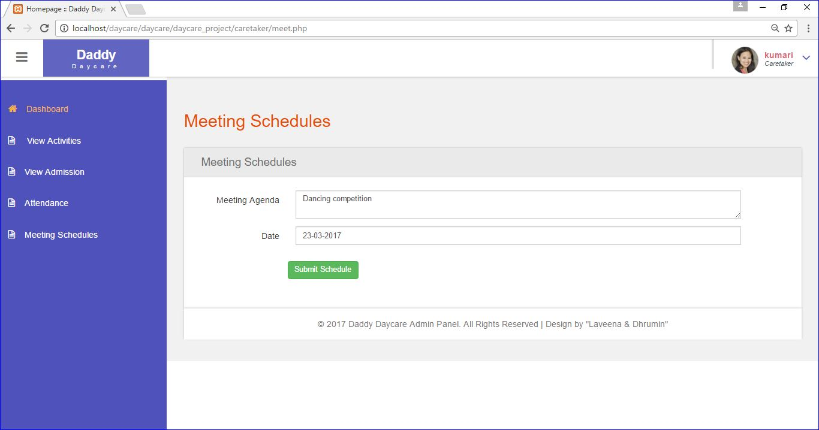

CareTaker Logout

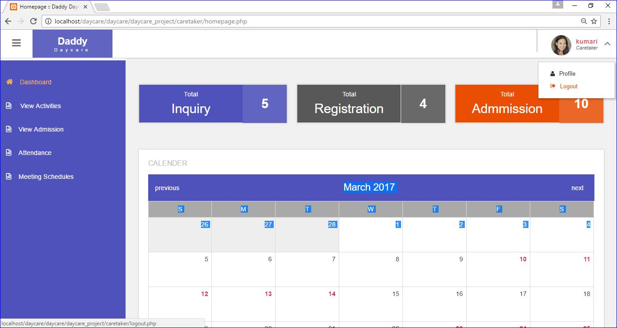

**User Side**

HomePage(Before Login)

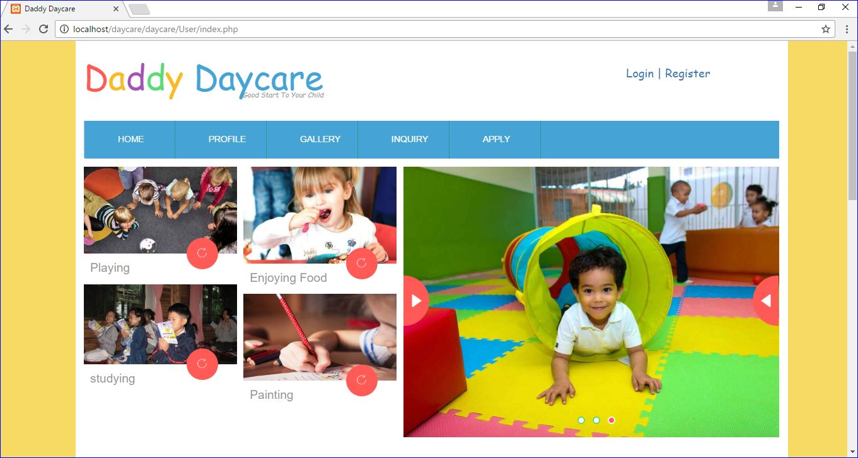

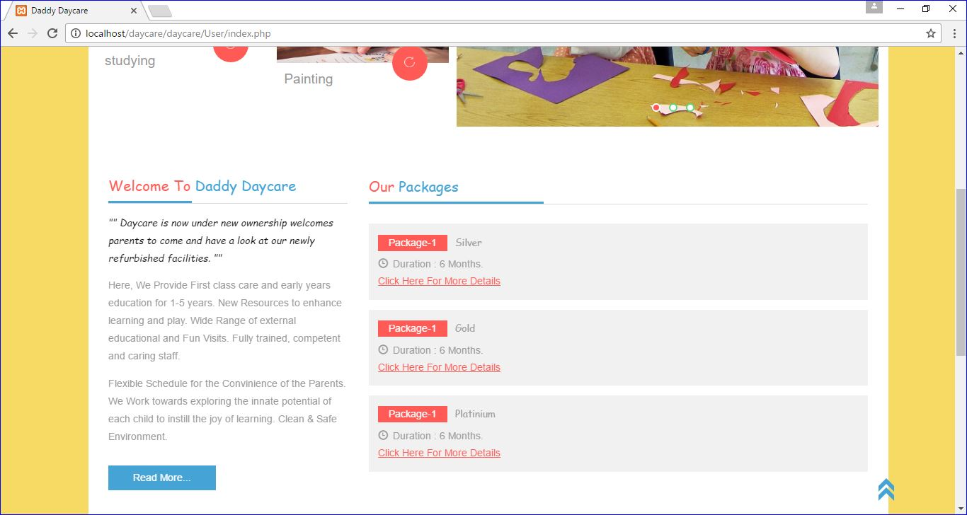

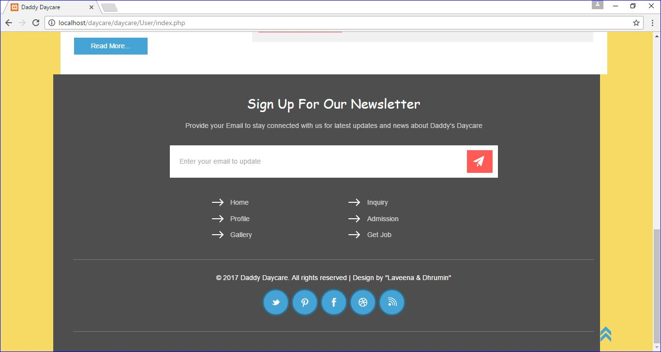

Profile

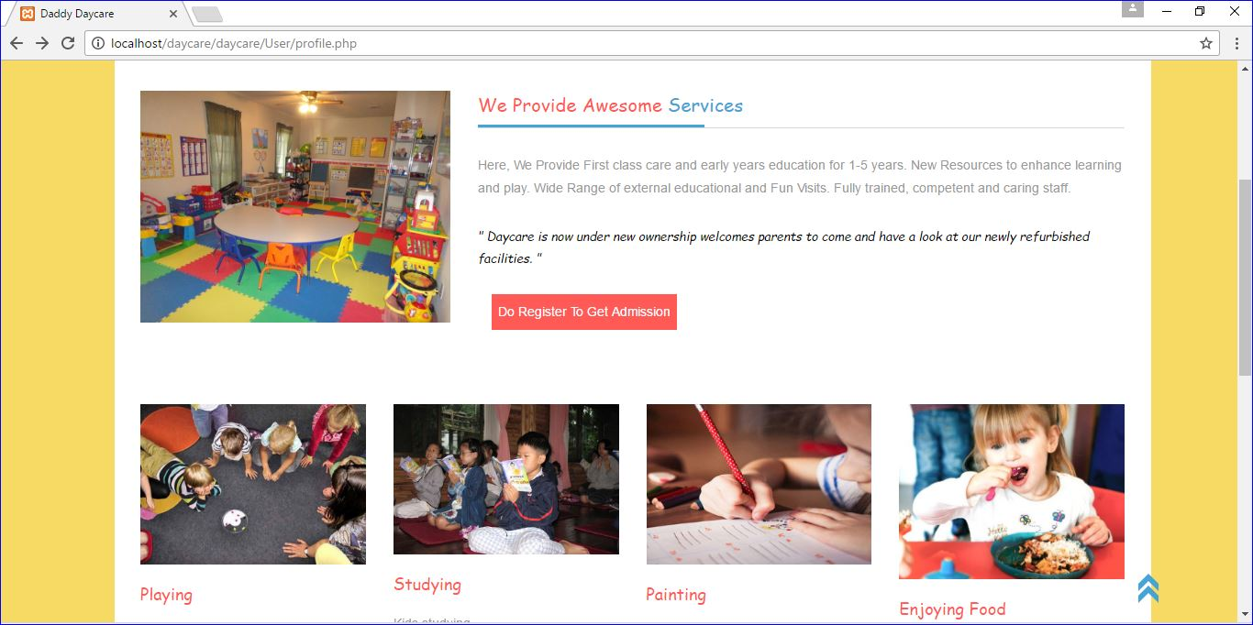

Gallery

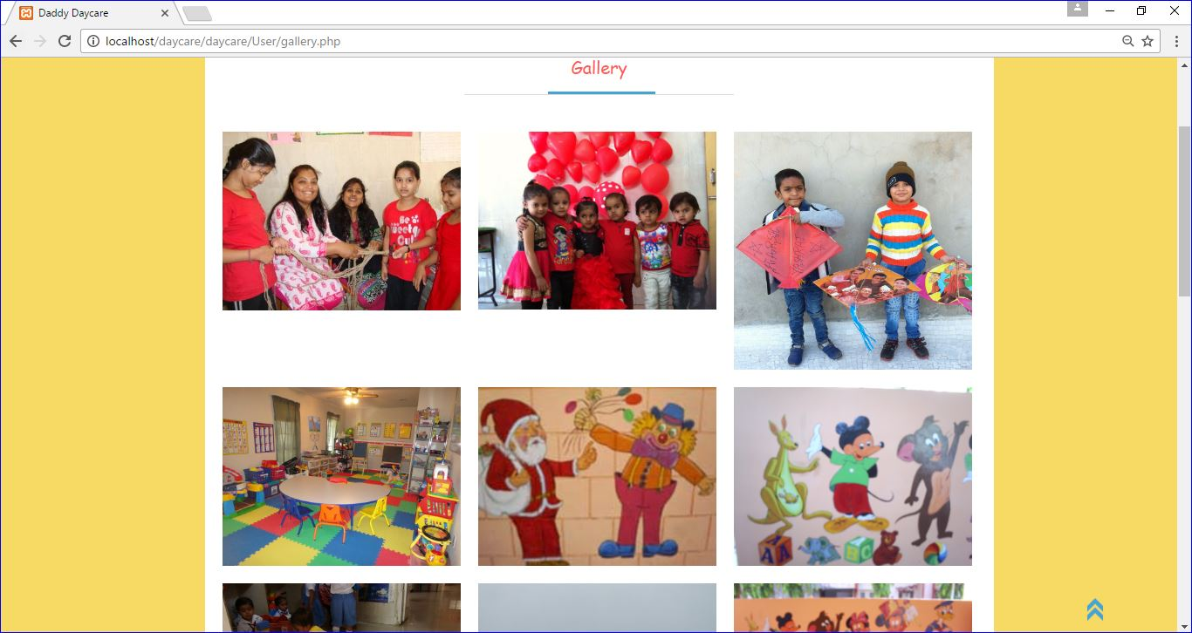

Inquiry

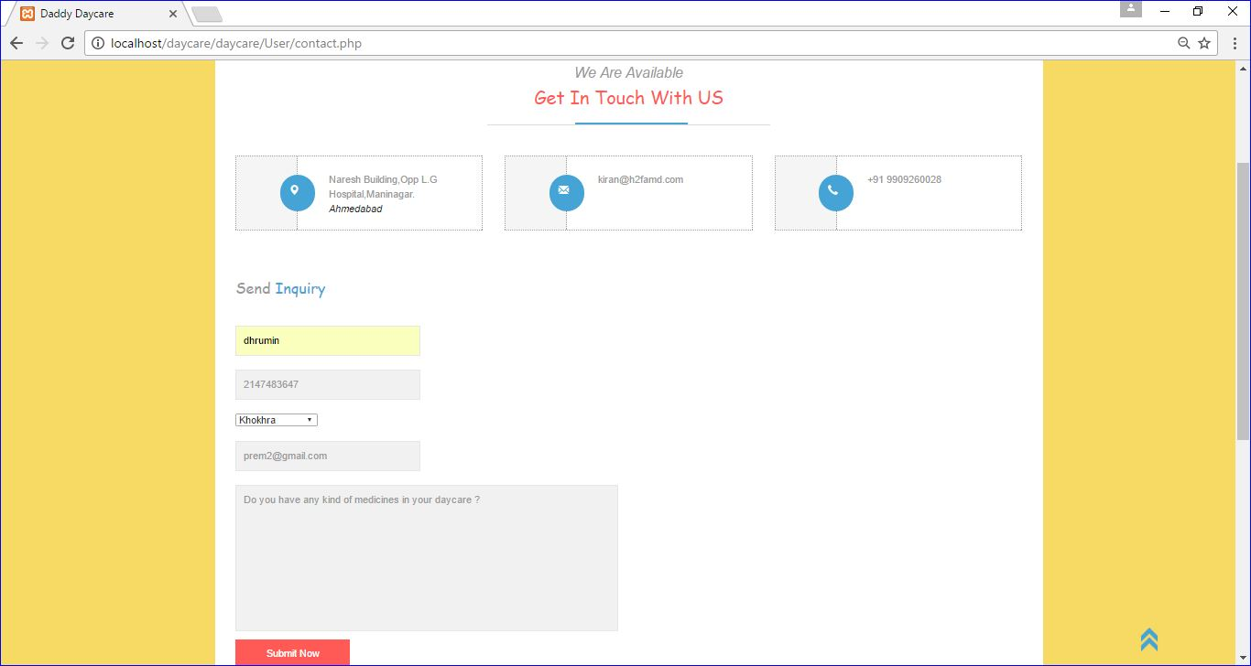

Apply For CareTaker

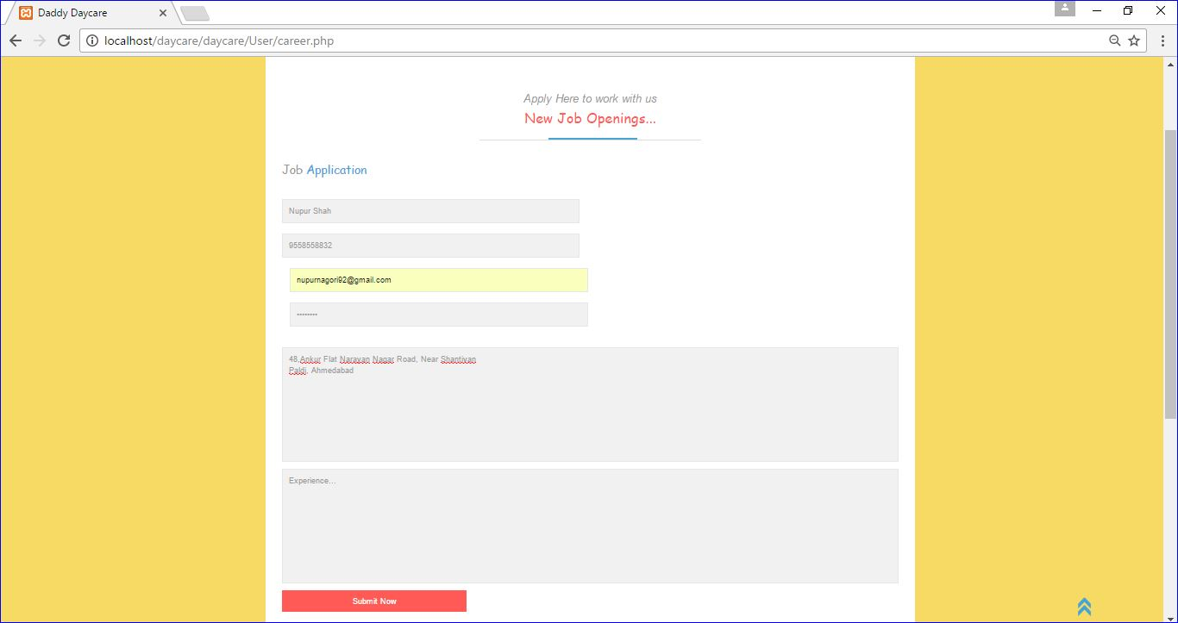

Registration

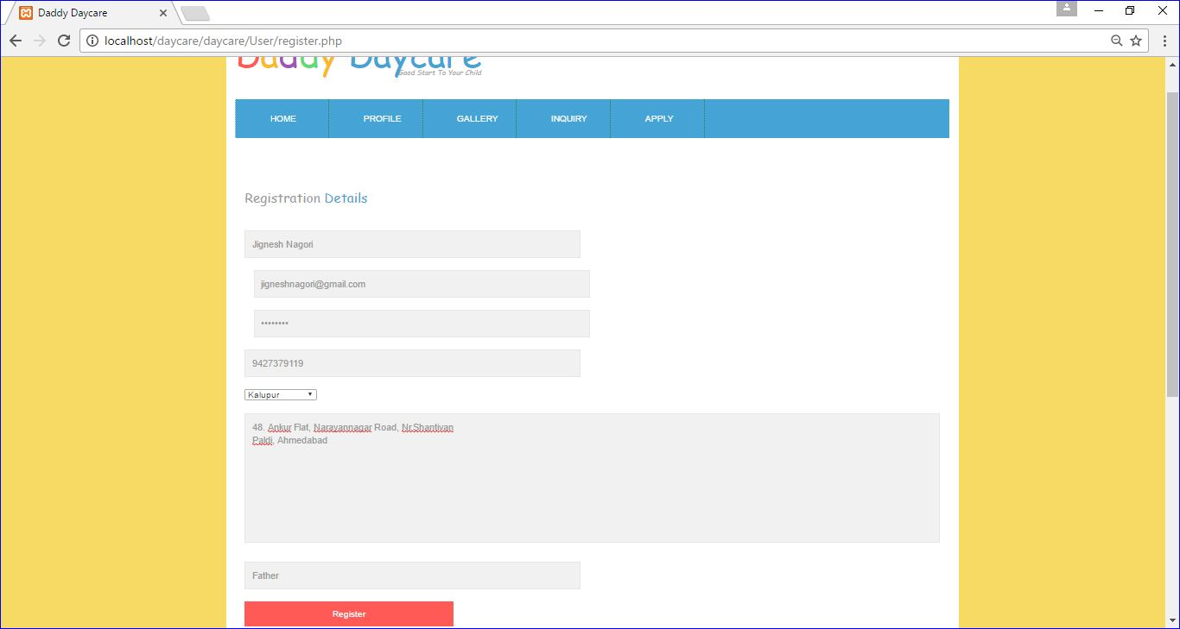

Validation In Registration

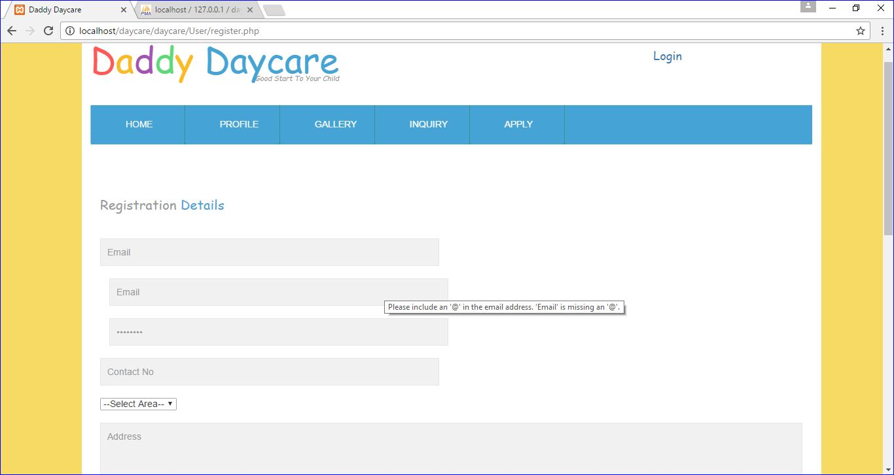

Login Of Registered People

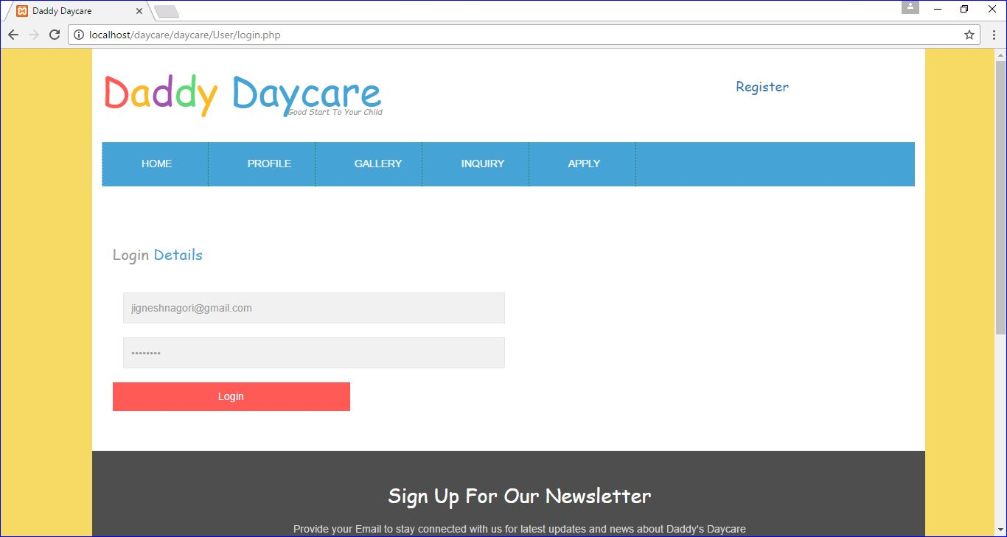

Validation In Login

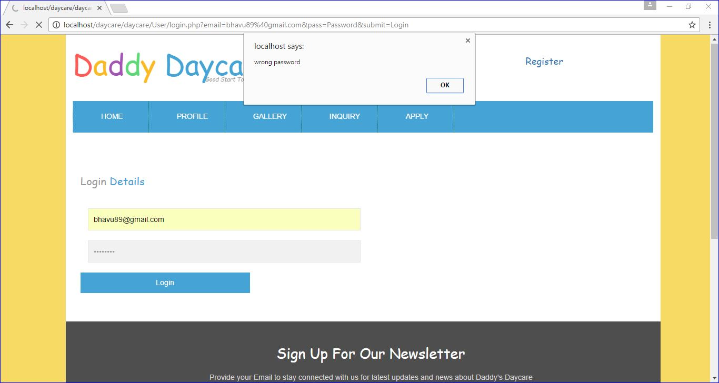

After Login

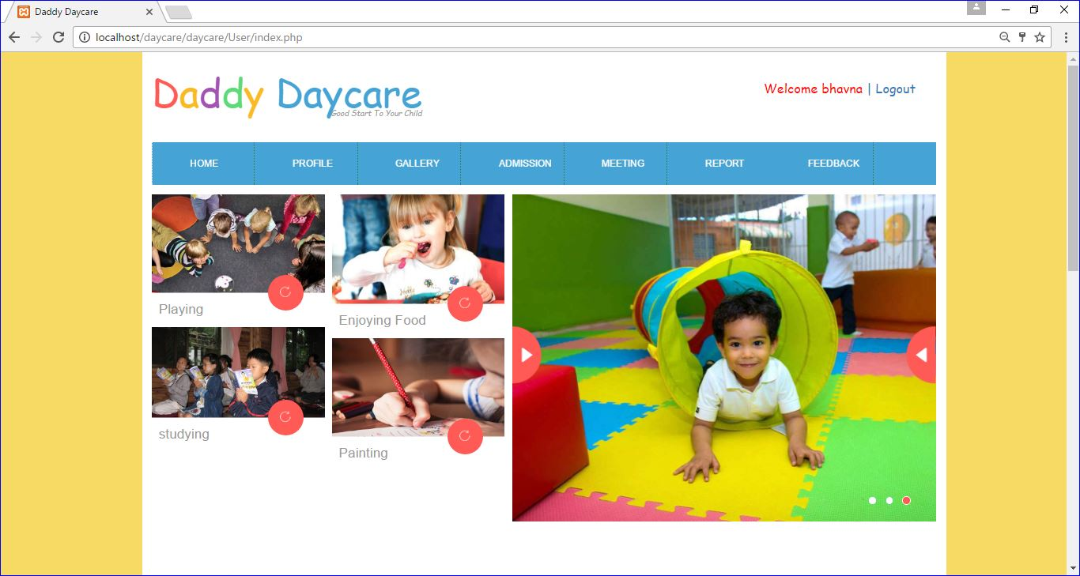

Admission Page

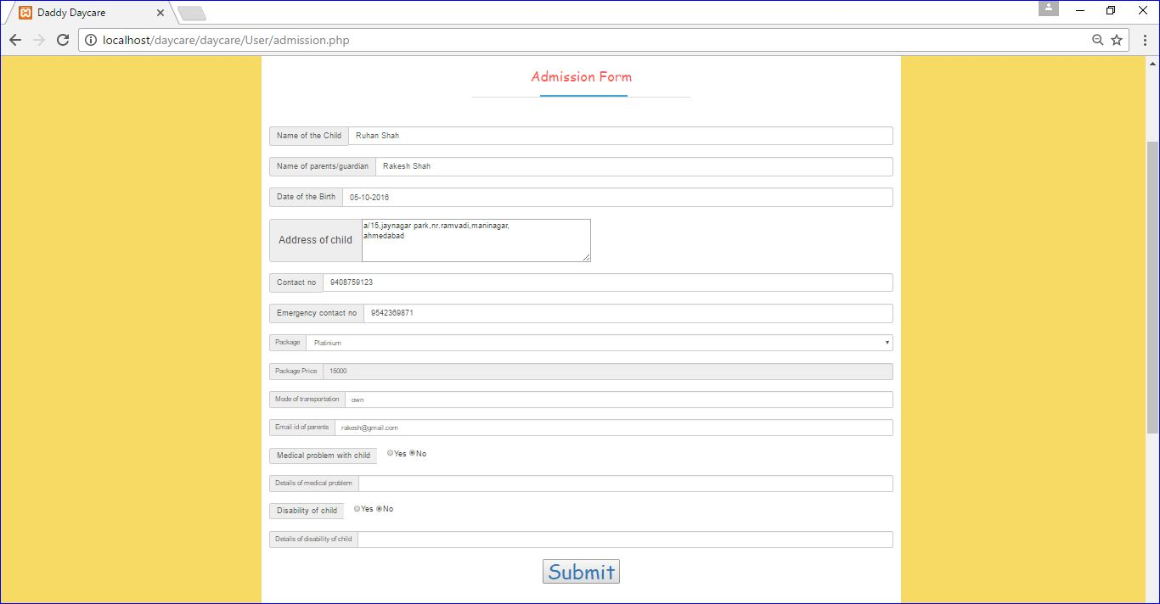

Implementation of Ajax in Selection Of Package

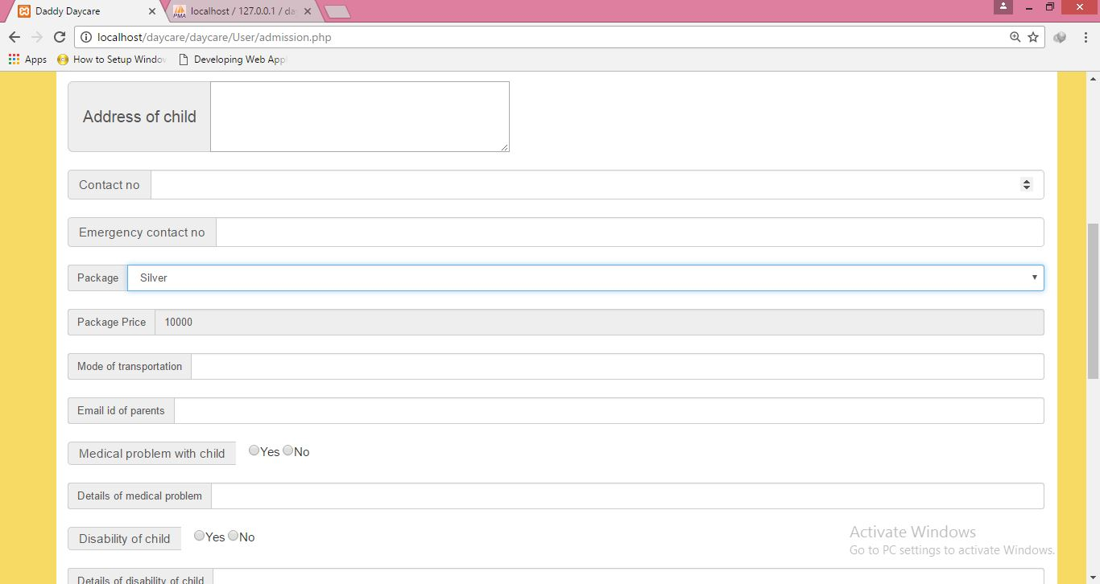

View Meeting Schedules

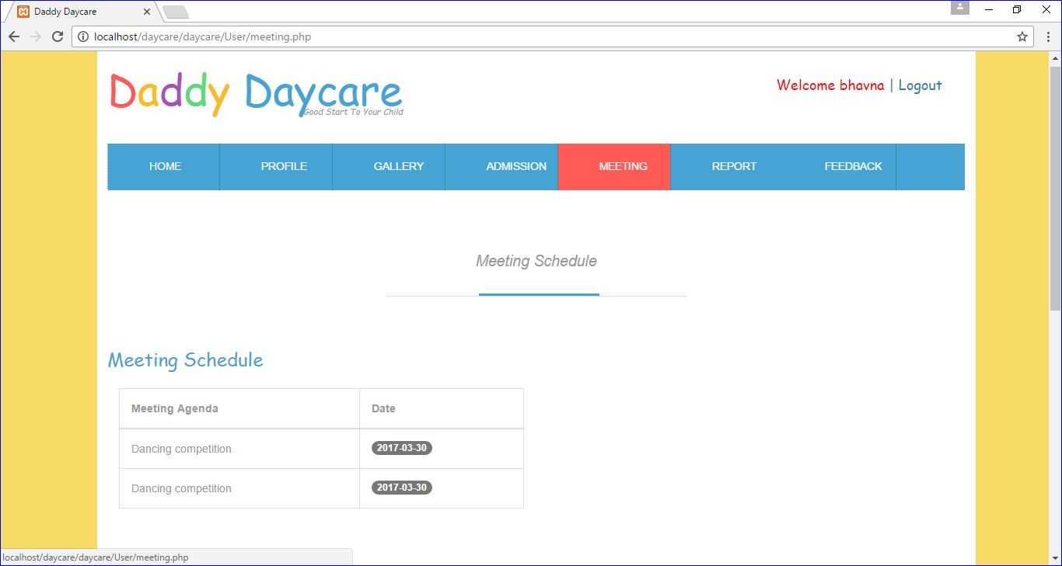

View ReportCard

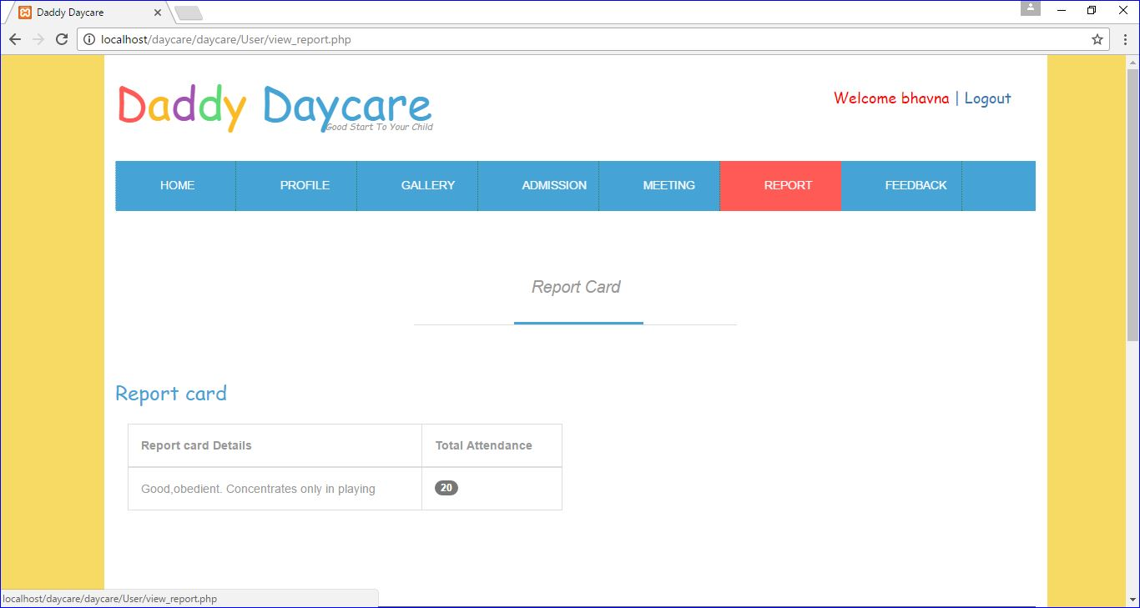

Give Feedback

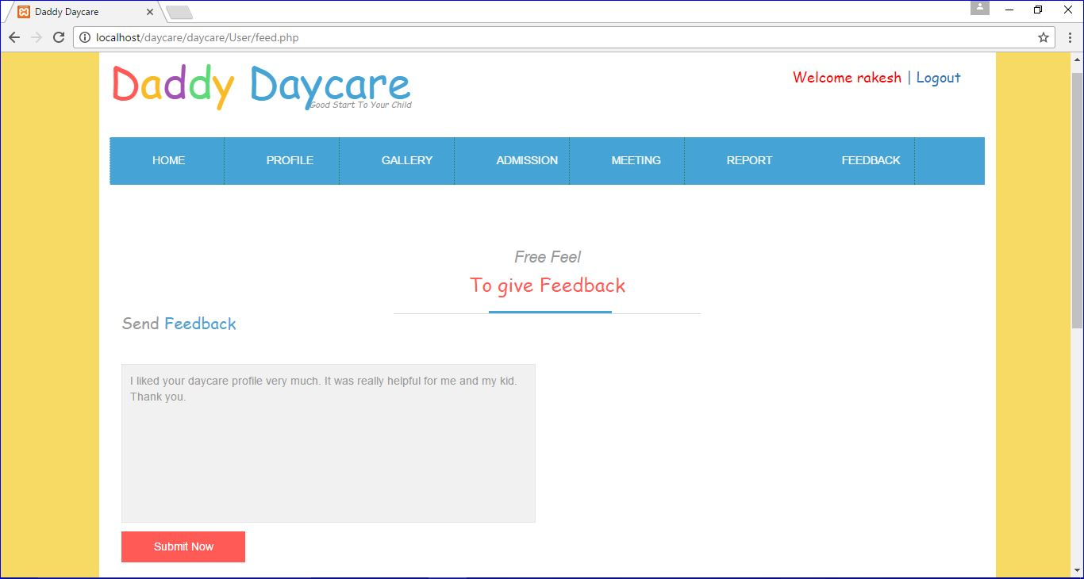

Report Layout

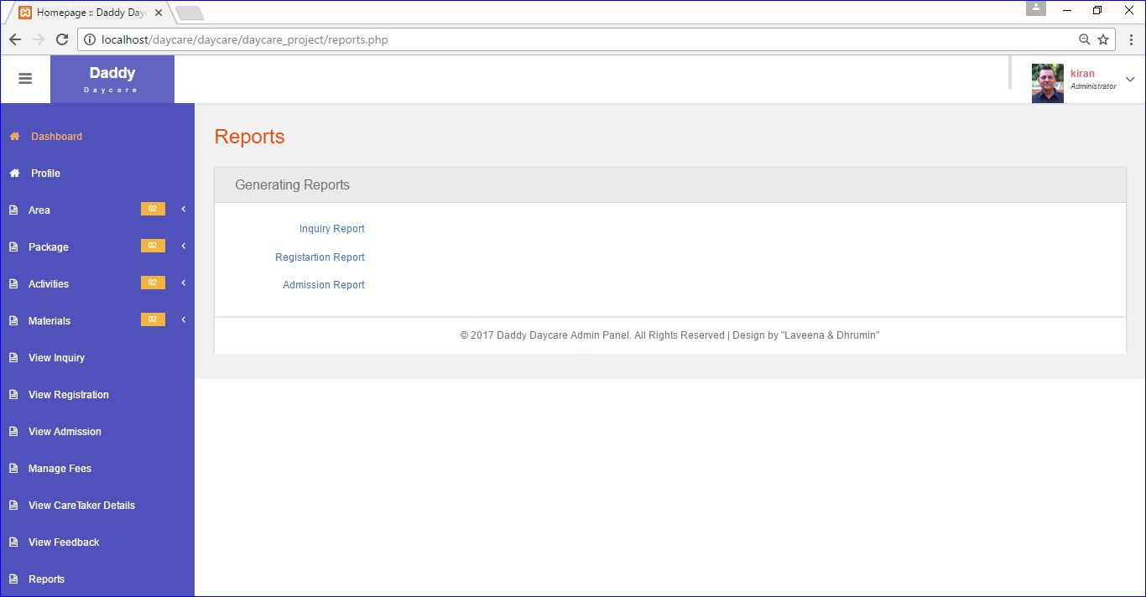

Inquiry Report

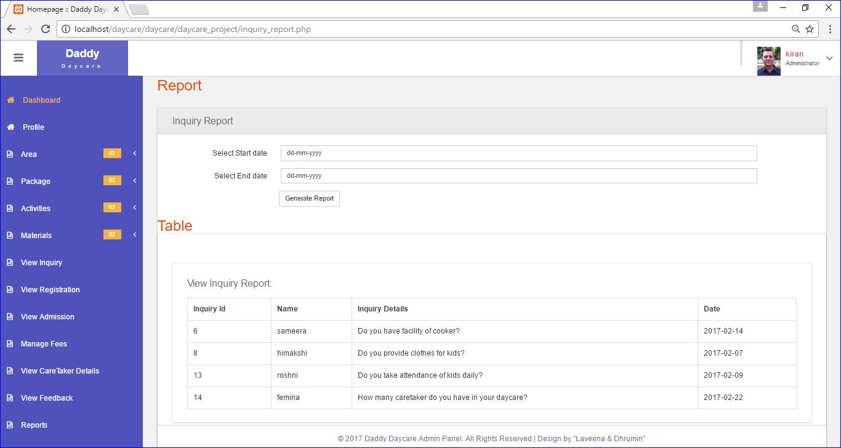

Registration Report

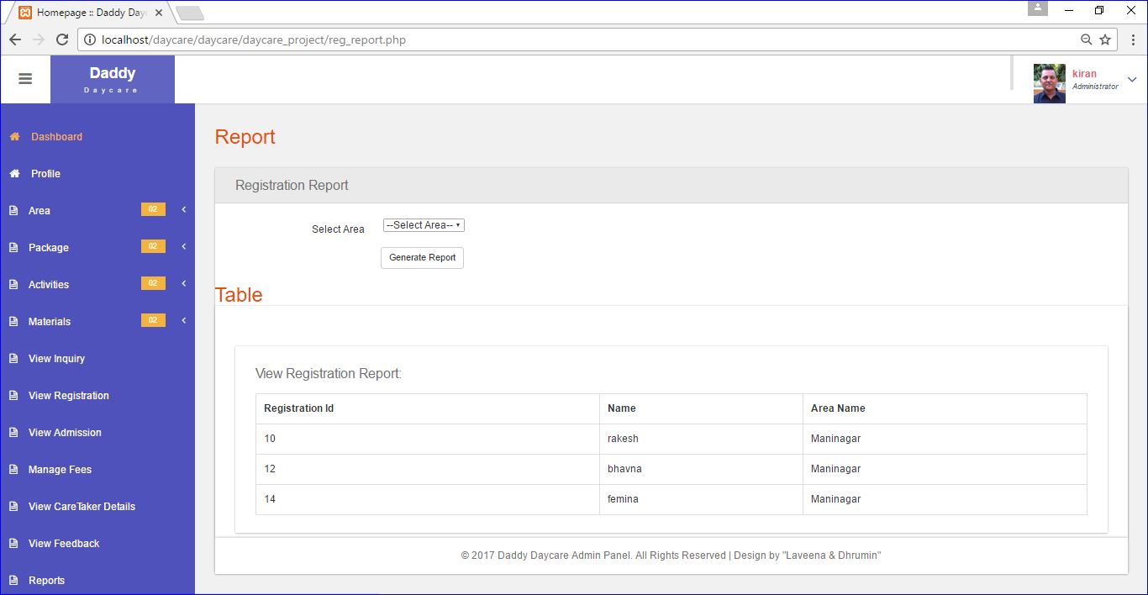

Admission Report

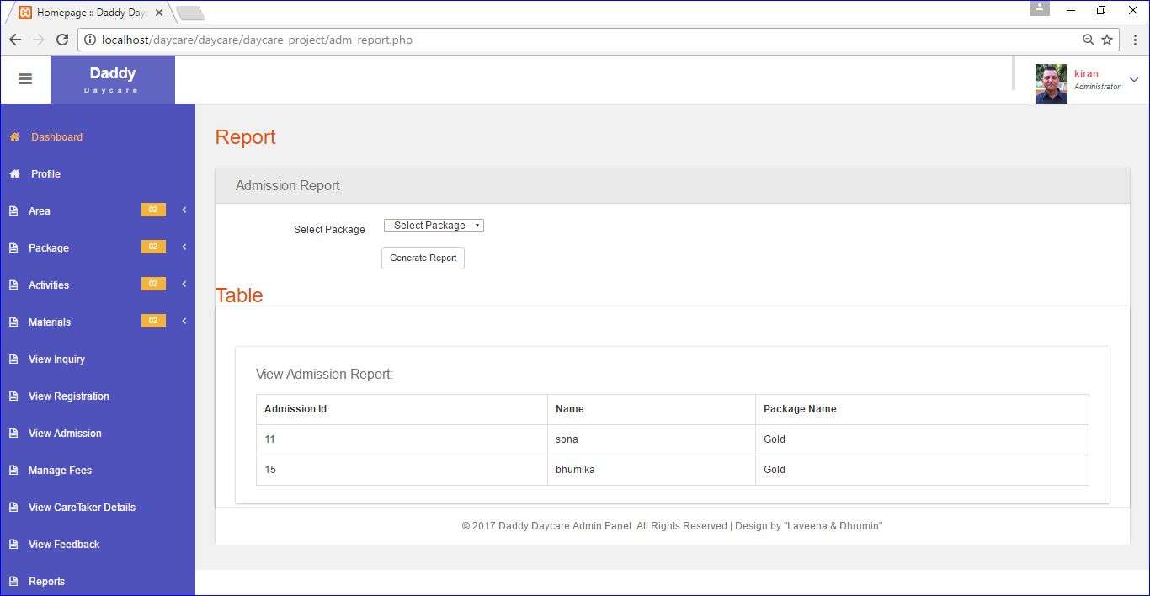

Bibliography

* Reference Book :-

Magnifying Object-Oriented AnalysisAndDesign.

Authors:- Arpita Gopal & Neeta Patil.

Publisher:- PHP Learing.

* Internet:-

[www.W3schools.com](http://www.W3schools.com)

www.phptut.com

Conclusion

* At the end of our project we concluded that it was a very nice experience in doing this project.
* We have now successfully completed the Second Phase of our Daddy Daycare Project.
* Thus, we thank to our Internal Guide “Mrs.Trpiti Dodiya” for guiding us throughout the project and to our external guide “Mr.Kiran Nagpure” for helping us in project.